**Module 2 Task 1**

1. Create an Instance in us-east-1 (N. Virginia) region with an Ubuntu OS and install Nginx for making them web servers.
2. Change the default website with a hello world page

**Solution**

1. Log into the AWS Console:

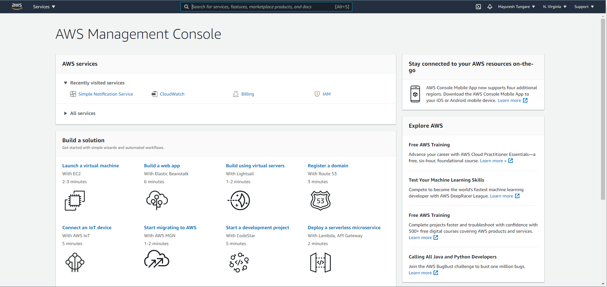

1. Click on to ‘Launch a virtual machine’

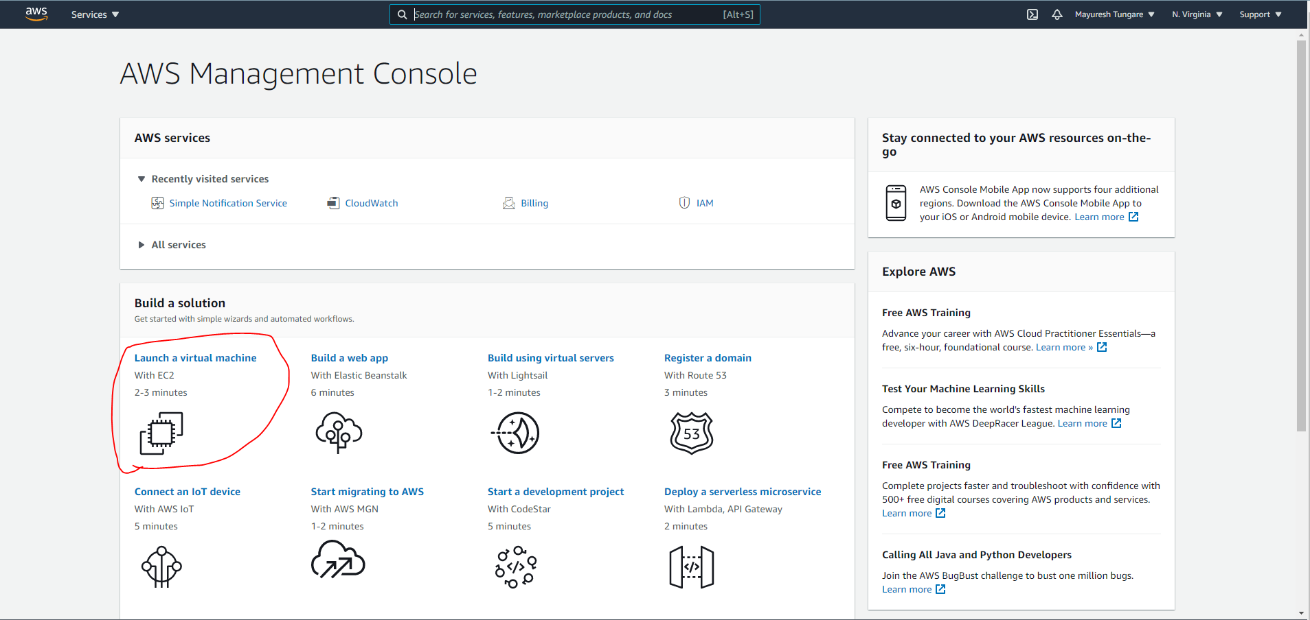

1. Select the Ubuntu Server 20.04 LTS (HVM), SSD Volume Type

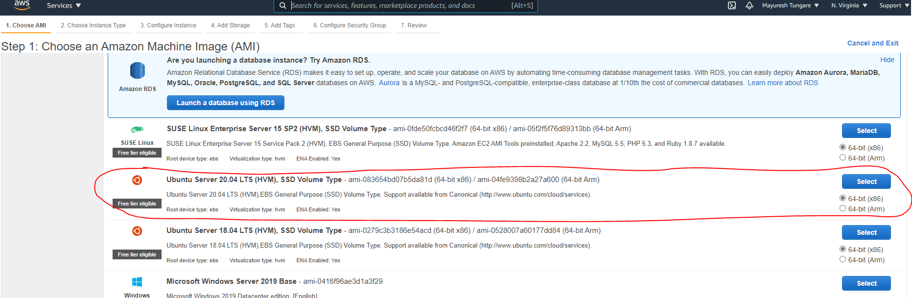

1. Select t2 micro instance type (it is free tier eligible).

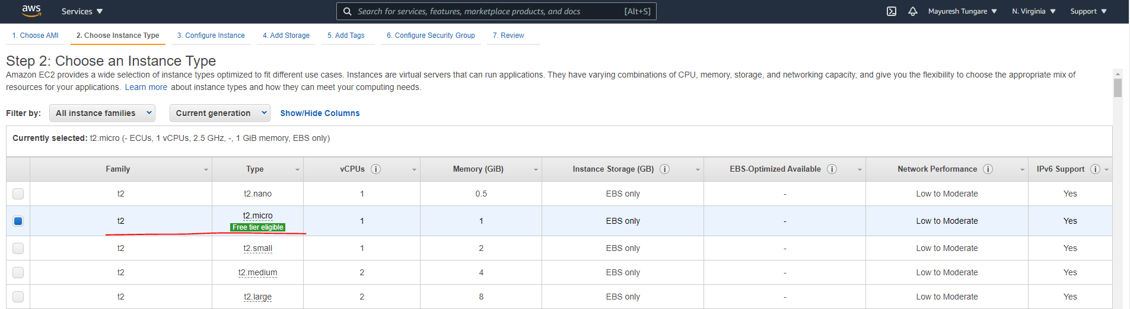

1. On Configure Details page, enable termination protection.

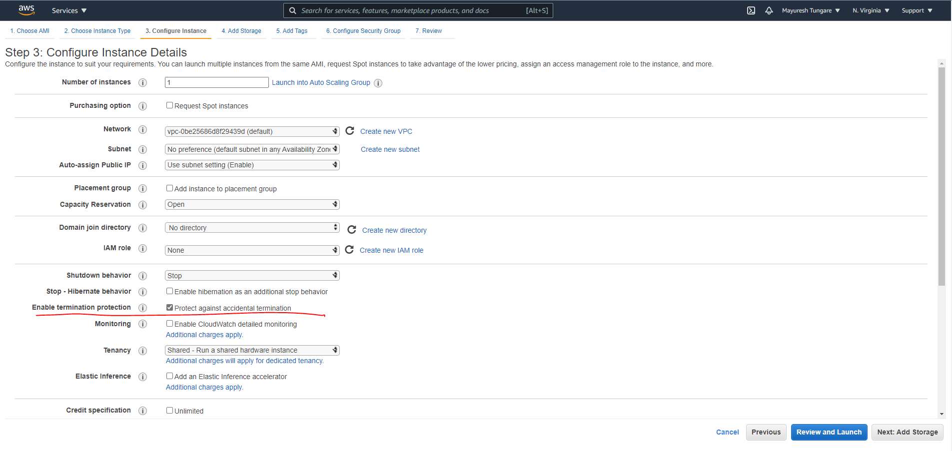

1. In the next step, add storage and increase the volume to 30 GB (30 GB is the permissible limit for free tier usage).

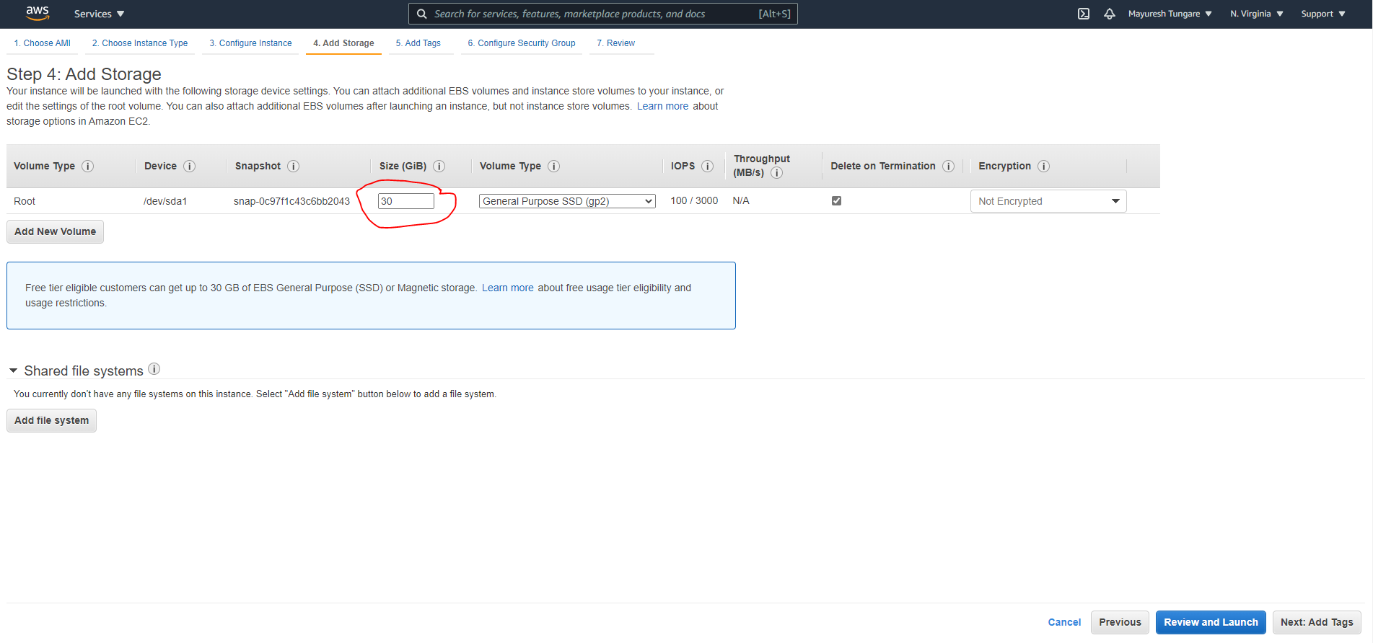

1. In the next step, add tags to the EC2 instance

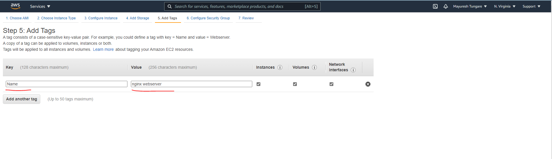

1. Click on add rules to add rules to Configure Security Groups

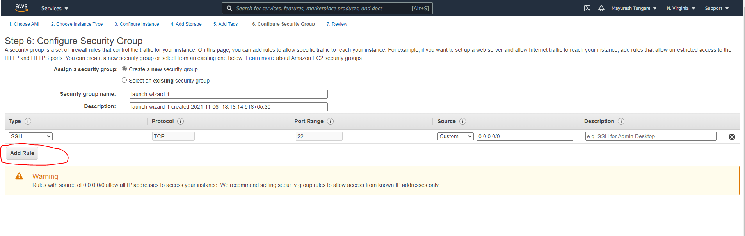

1. Add rules to Configure Security Groups and click on Review and Launch

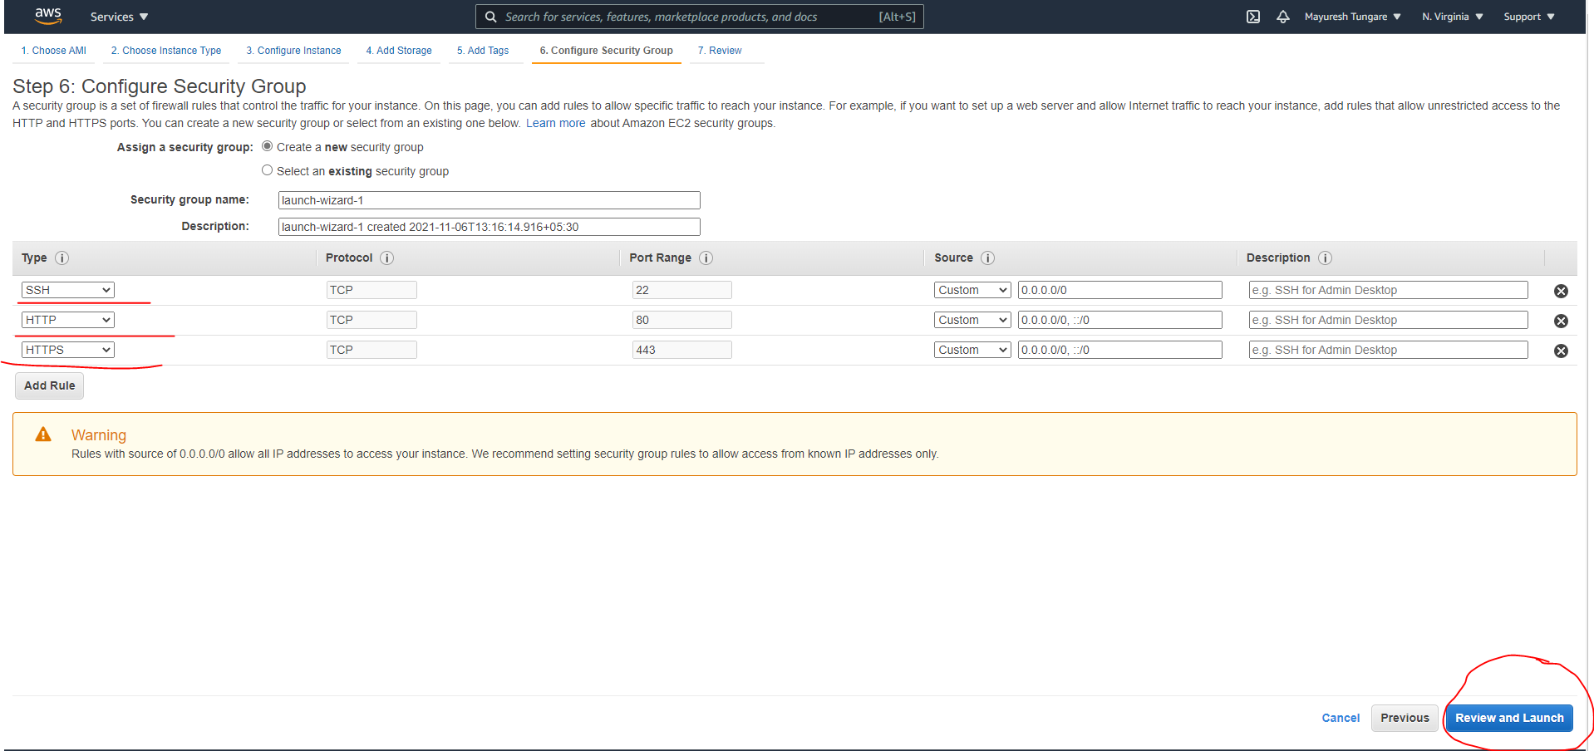

1. After you click Launch, you will be asked to create a key pair (key pair can be downloaded only once when launching an instance).
2. After your instances have been launched, you will see the following message:

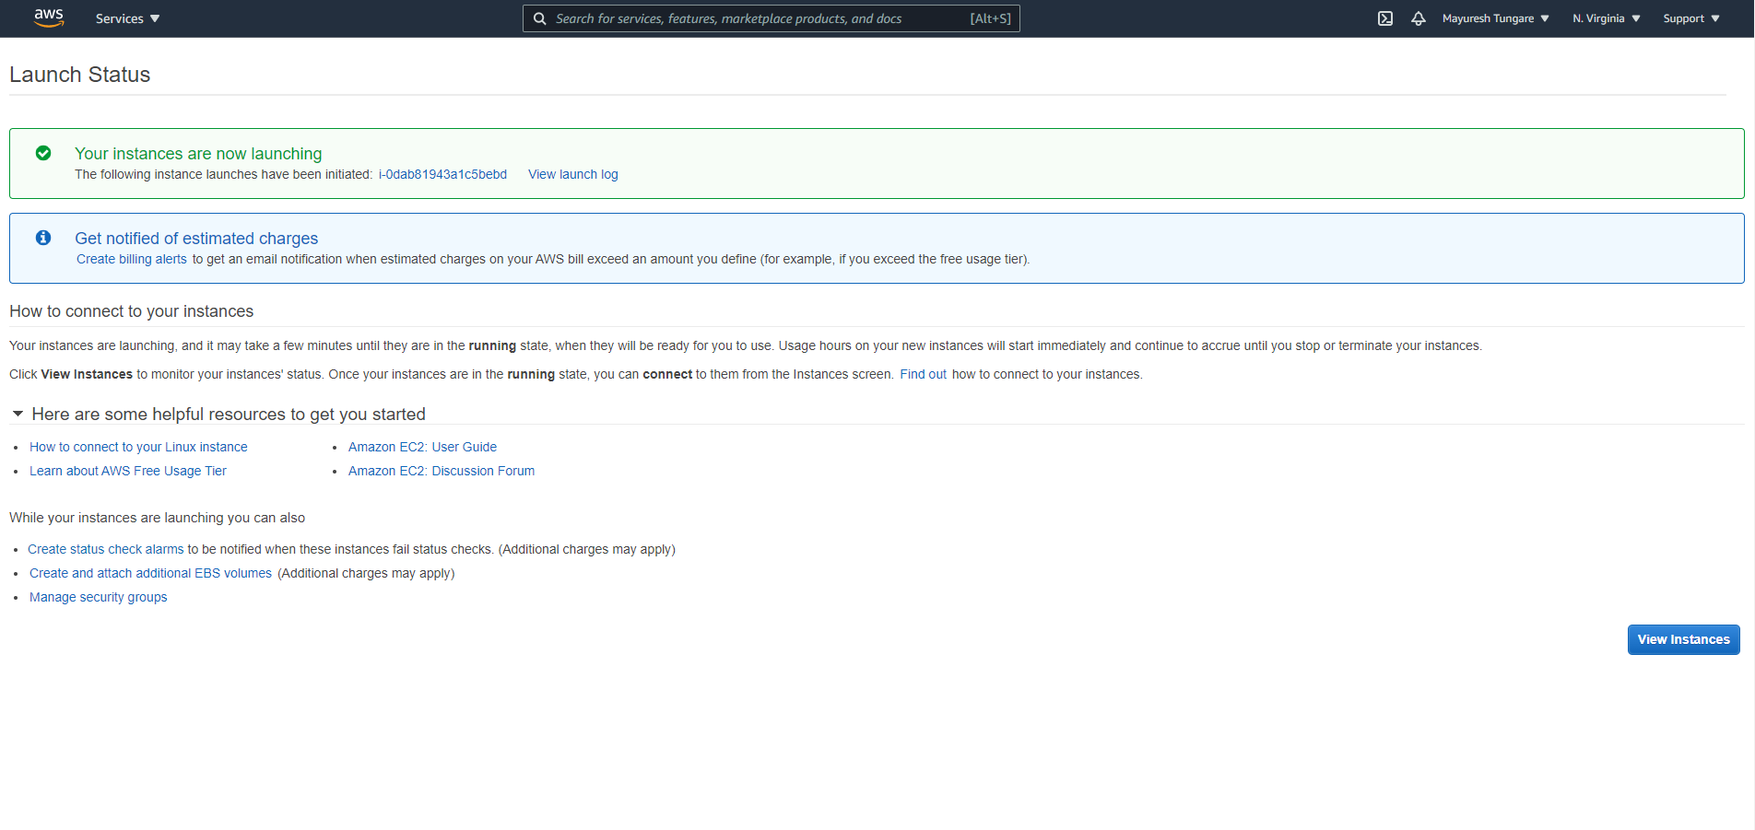

1. You should be able to see your instance up and running on the AWS console. Please note the public IP address that you will need to use to log on to your EC2 instance.

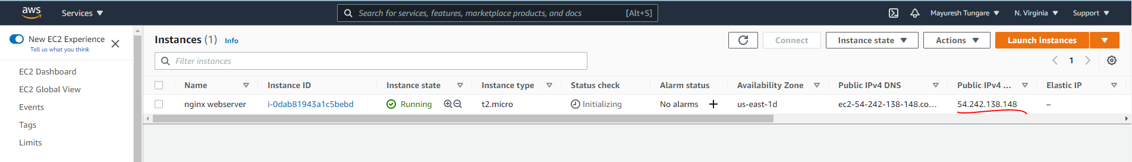

1. Now open a Linux terminal on your desktop and enter the following command:



1. You should be able to login to your instance and see the following message on the terminal.

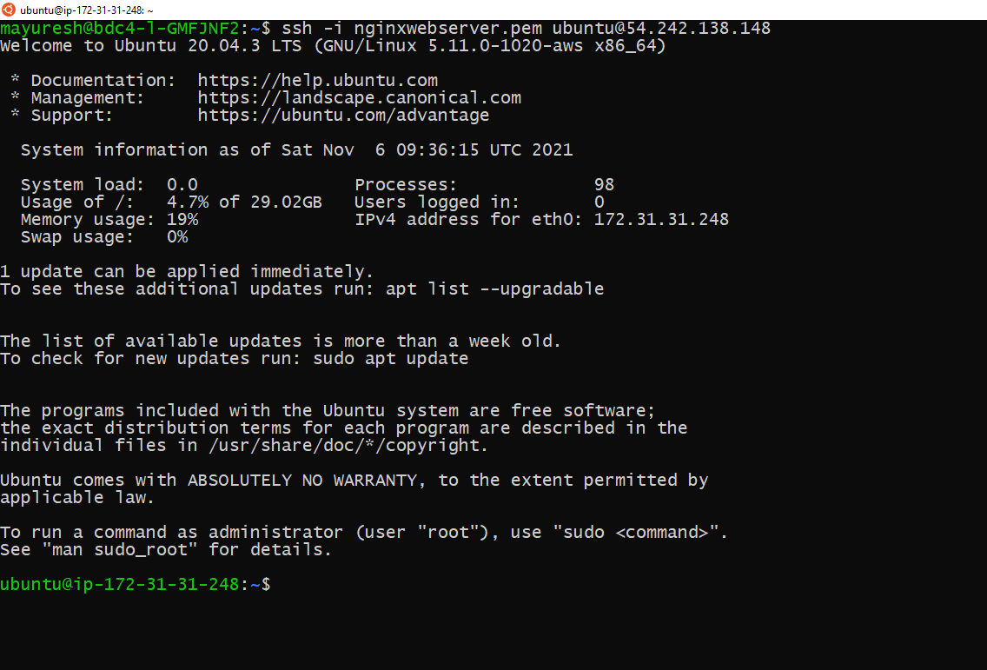

1. After logging into the system, please install nginx server using the following command:



After nginix is installed

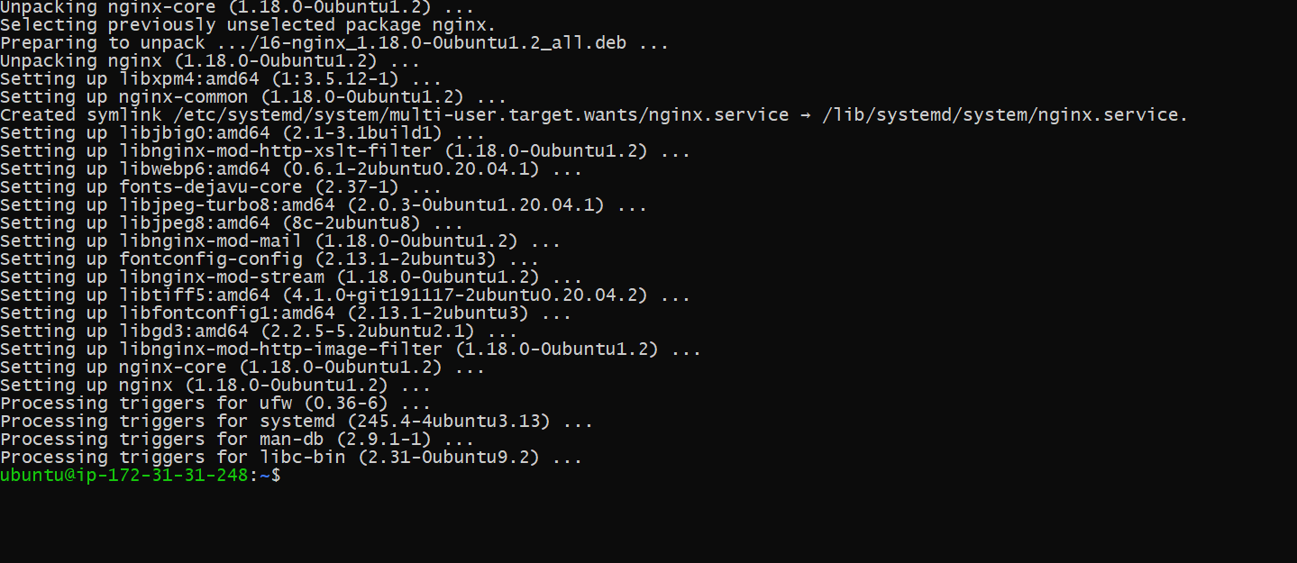

1. Check if nginx is running. If not, then start nginx service

In my case, nginx is already running:

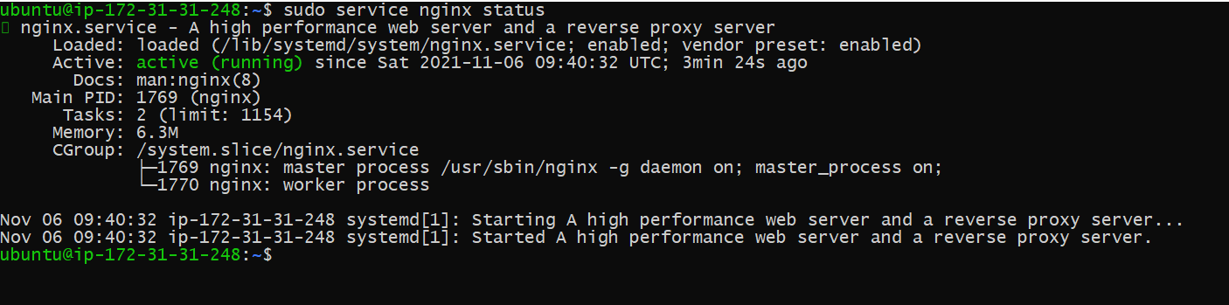

1. You will now see Nginx installed when you

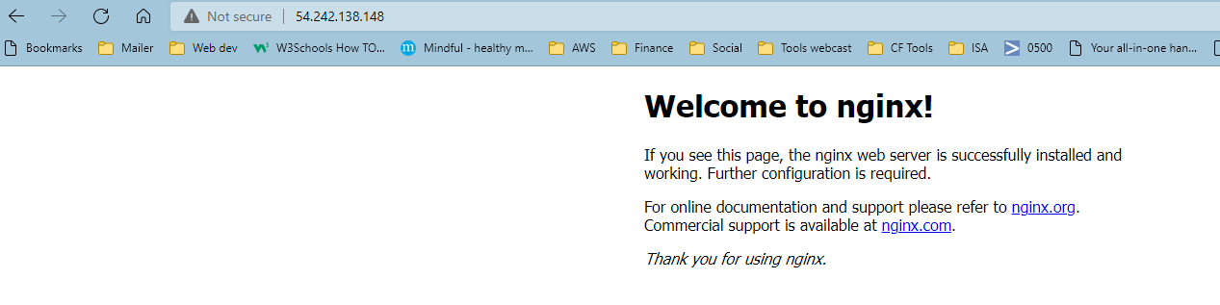

1. Go to Location /usr/share/nginx/html and update the index.html file

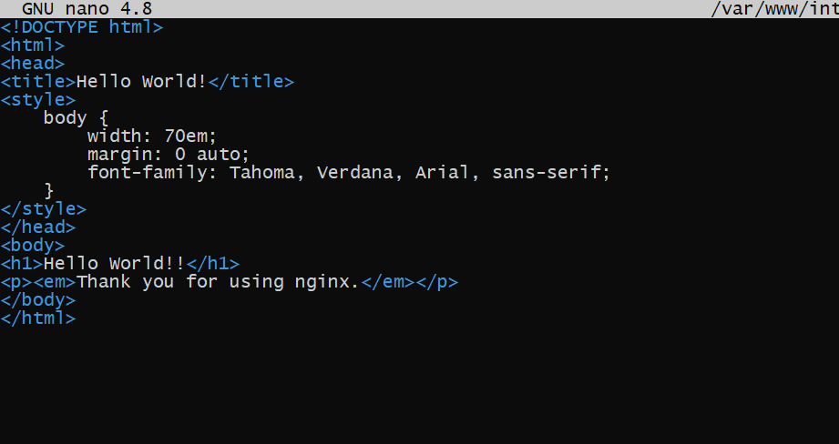

1. We also need to update the default file



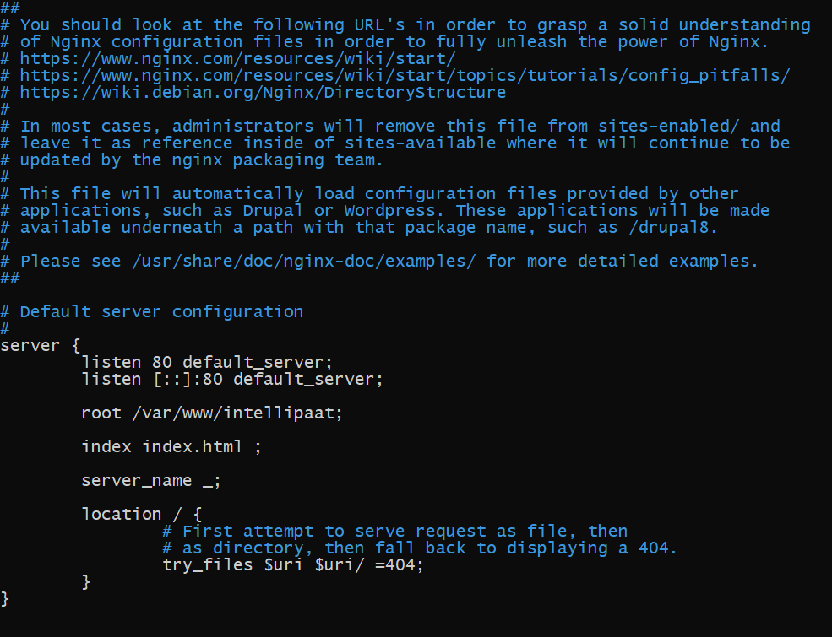

1. Once updated the, we can check on the browser on the given IP address and see that the index.html is updated and we see the updated message.

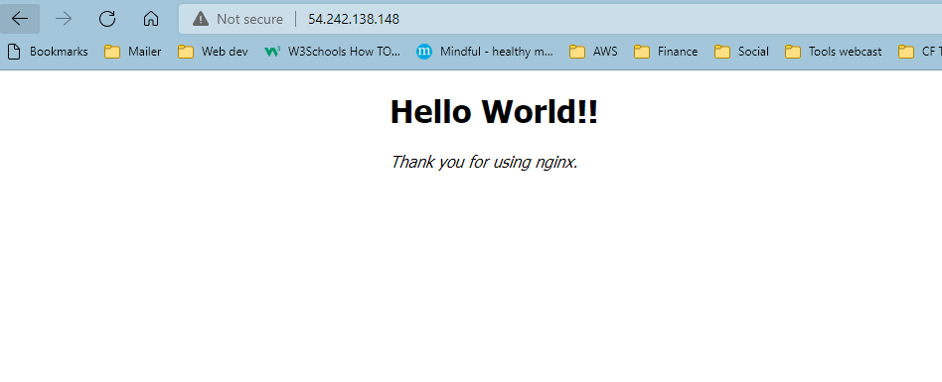

1. With this, assignment 1 is now complete.